Title: | Instrument Panel Cluster

History
Issue status  (Index) | Maturity/Date  (draft/invalid/valid)  (dd-mmm-yyyy) | Author  Department | Check/Release  Department | Description
1.0 | Draft  04-0ct-09 | Miguel Garcia | Miguel Garcia | Creation of the document
1.1 | 1-Revision  27-Aug-15 | Pedro Romero Hector Cuellar | Ricardo

Table of Contents
1 Purpose 3
2 Definitions and abbreviations 3
3 Realization constraints and targets 3
4 SW Component internal breakdown 4
4.1 Functional Decomposition 4
4.2 Function <Type> <function name> (type par 1, .., type par n) 5
4.3 Function <Type> <function name> (type par 1, .., type par n) 5

Purpose
This panel consists of a series of elements that display information to the user in order to report some of the most important parameters of the car, placed in front of the driver of an automobile, housing instrumentation and controls for operation of the vehicle.

For this software design the odometer, speedometer, gas gauge indicator and other visual indicators has to be emulated using LEDs, 7 segments displays and a stepper motor. Also al the communication is performed by CAN protocol.

Definitions and abbreviations
Definitions
IPC Instrument Panel Cluster
PIT Periodic Interrupt Timer
GPIO General Purpose Input Output

References
N° | Document name
1  2 |  | PFinal-ID_Cluster Requirements.doc  Traceability Matrix.xls

Realization constraints and targets
- The instrument panel proposed for this practice will consist of:
  - 1. Speedometer
  - 2. Odometer
  - 3. Fuel Gauge
  - 4. Visual Indicators
- The CAN signal will be provided by the ATV
- The status of ignition will be provided by the AVT
- The speedometer should be able to indicate the maximum vehicle speed in km/h
- The speedometer will receive a speed signal by CAN when the ignition is on, and performs signal processing to indicate speed.
- The value of speed is updated every time a CAN signal arrives
- The response latency must be equal or less than 300 msec for all increments or decrements.
- The odometer have to show in the display the value of the total distance traveled by the car in units of kilometers.
- This value is updated in the display every 200ms.
- The total distance traveled by the car must show in the odometer at power the unit and never lose its value.
- Upon receiving the signal to increase odometer (ODO INCREASE), the total distance is updated, after receiving it and record it, must answer with the message (ODO ACKNOWLEDGE) as shown in the command section.
- The TRIP ODO has a button that the user presses to set this value to zero and make a new measurement.
- The TRIP ODO shows the distance traveled with one digit after the decimal point.
- The software must ensure that the odometer never display a value less than value traveled, if this value was altered ODO must show an error message in the odometer
- The level is displayed by a 5 LEDs bar considering a scale of 0 to 1
- The initial presentation from 0% to tau will be held in 4 seconds gradually.
- If the speed exceeds 5 km / h and the message indicates an open door, the indicator should turn on
- If the belt is not buckled, there are two stages:
  - Initially when the car starts and the position of the gearbox is in drive (D), the indicator lights.
  - If the vehicle travels at more than 10km / H, in flashes.
- The gas indicator should turn on when the fuel level is less than or equal to one eighth of the maximum tank level.
- This beams indicator is activated when the high beams message arrives
- This break indicator is activated when the hand break message

SW Component internal breakdown
UML Diagrams content:

- Uses Cases Diagram
- Component Diagram
- Activity Diagram
- Sequence Diagram
- State Diagram

Functional Decomposition
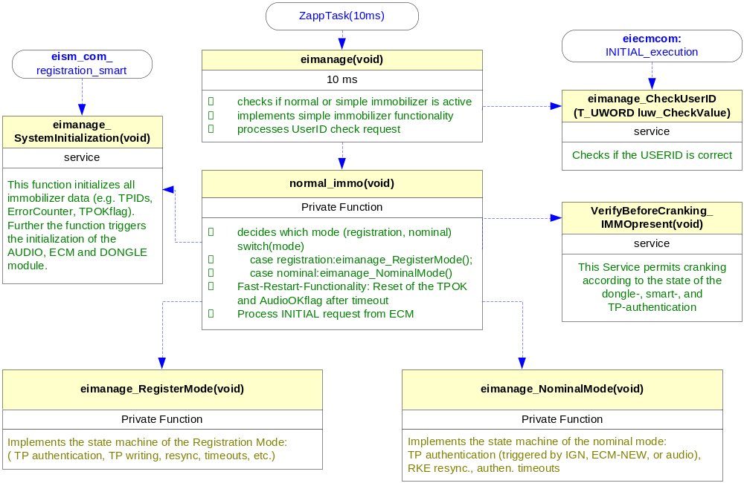
Function Description and Dynamic Behavior

Function <Type> <function name> (type par 1, .., type par n)

Description | Brief description of the function behavior and useful remarks
Parameter 1  <input| output| inout> | Give an explanation if the parameter shall be checked by the user, or if a check is implemented in the function here
Parameter 2..n
Return Value
Precondition | e.g. Function can only be called in a certain state, SW component is initialized  Relation between input parameters where applicable (Input for Module Test)
Post condition | e.g. specific State change e.g. car is locked, EEPROM Values written,  Relation between output parameters where applicable
Error Conditions

Dynamic Behavior
State Chart¹, Flow Chart¹
¹ Preferred
In this document, the dynamic behavior shall be designed on an abstract level showing the principle workflow of a function. Do not show the detailed implementation to ensure that the design description can be maintained with a reasonable effort. The target is not to show the complete detailed implementation 1:1.
The detailed design shall reflect in detail what a function is doing from a black box view. The internal details are useful on an abstract, but not very detailed level.
If the function is not complex a short textual description might be sufficient and a graphical description is not needed.
Symbol and function names shall be self explaining.
The link to the implementation may be provided by using the same names as in the design or by a comment showing the full name followed by the declaration showing the implementation.

Function <Type> <function name> (type par 1, .., type par n)
Description | Brief description of the function behavior and useful remarks
Parameter 1
<input| output| inout>
Parameter 2..n
Return Value
Precondition | e.g. Function can only be called in a certain state, SW component is initialized  Relation between input parameters where applicable (Input for Module Test)
Post condition | e.g. specific State change e.g. car is locked, EEPROM Values written,  Relation between output parameters where applicable
Error Conditions

Dynamic Behavior
State Chart¹, Flow Chart¹, Nassi Shneiderman
¹ Preferred
In this document, the dynamic behavior shall be designed on an abstract level showing the principle workflow of a function. Do not show the detailed implementation to ensure that the design description can be maintained with a reasonable effort. The target is not to show the complete detailed implementation 1:1.
The detailed design shall reflect in detail what a function is doing from a black box view. The internal details are useful on an abstract, but not on a very detailed level.
Symbol and function names shall be self explanatory.
The link to the implementation may be provided by using the same name as in the design or by a comment showing the full name followed by the declaration showing the implementation.

Macros

Only complex macros shall be described here. A complex macro is longer then one line or has more then one parameter or command. A complete description of all macros shall be done by code comments.
Be aware: macros shouldn’t be part of the interface: Don’t use macros at interface level!
If you still think you need macros: document them like functions.
Internal Interfaces
For internal interaction a data flow and/or a message sequence chart shall be provided. If the Static Function Tree already contains a data flow description then just reference it

SW module global variables
Where shared variables can not be avoided, a risk analysis is mandatory.
Name | Type | Memory section | Description | Shared
Klstrg_status | T_UBYTE | NON_INIT_RAM | Status of terminal control | X

Design solutions for general features
It should describe detailed design solutions for general features of our products. i.e ”Layer Programming”

SW Component integration

Integration context / constraints
Tbd: help text

Include files
List here the necessary include files and their order,

Initialization
e.g. Sequence Chart for initialization
All function bellow shall be called on initialization
Call Order | Service | Call constraints linked to an other module
1 | BCM_Warning_Output_Init_Function | After EEPROM init

Interrupts
If described in the SW Architecture Document, just put the reference here.

Real time scheduler task
If described in the SW Architecture Document, just put the reference here.

Other entry points
Name | Service | Task level

